**Power BI Capstone Project Report**

This report is a key outcome of the Power BI Capstone Project to be submitted to Skillovilla team. It includes analysis of sales, revenue and orders etc. of ShopNest Store which is the leading department store in Portugal. The report starts with the dashboard prepared in Power BI followed by insights gathered by each visual in the process.

**Dashboard**

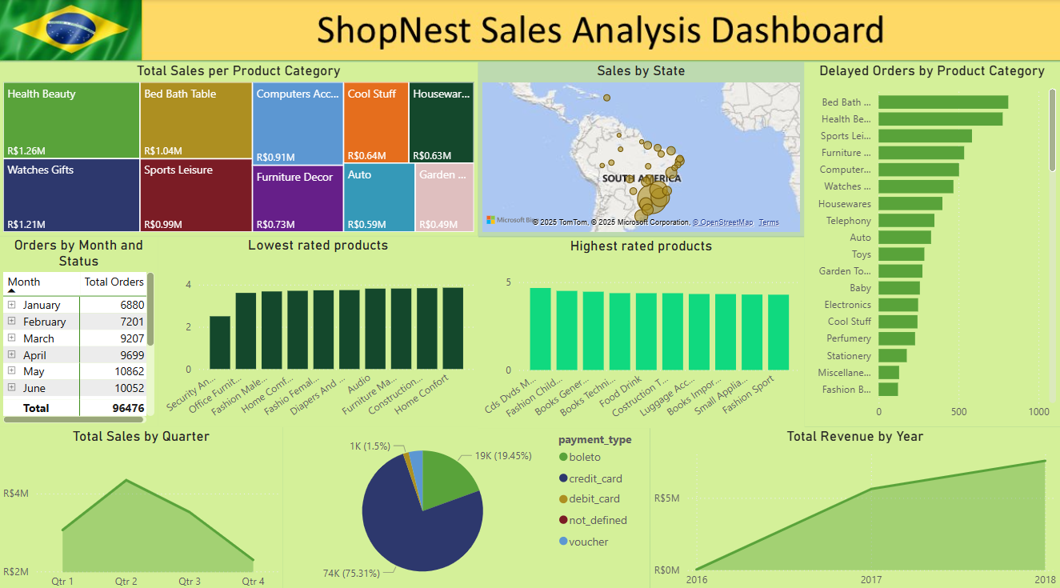

**1. Top 10 Categories by Total Price**

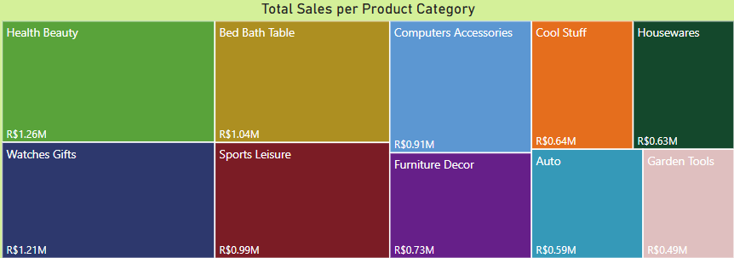

**Health Beauty** products were sold the most with sales **exceeding 1 million** Brazilian Real

with **Watches Gifts** being the close second. As it can be clearly seen, the products used in households frequently were sold the most.

**2. Delayed Orders Analysis**

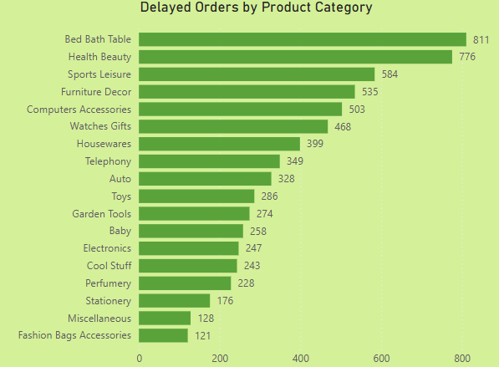

**Bed Bath Table** product category contains the most number of delayed orders followed by **Health Beauty** products. This may be due to supply-demand gap since these categories feature in **Top 10 product categories by sales**.

**3. Monthly comparison of delayed and on-time orders**

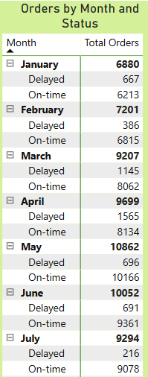For calculating total orders, we have omitted those orders from Orders table for which there was no order_delivered_customer_date. There were 8 orders for which the order_status was **delivered** and order_delivered_customer_date was missing. Hence, we can safely omit those 8 records out of nearly 100,000 records.

There is a gradual rise in number of orders from January to June with slight dip coming in July and again rising and eventually peaking in August with more than **12,500** orders.

In September, the number of orders fell sharply down to near **33%** of those in August.

From September onwards, the number of orders gradually rise again and there is more than **50%** increase in orders from November to December.

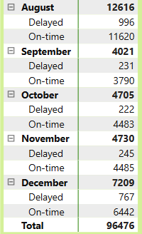

**4. Payment Method Analysis**

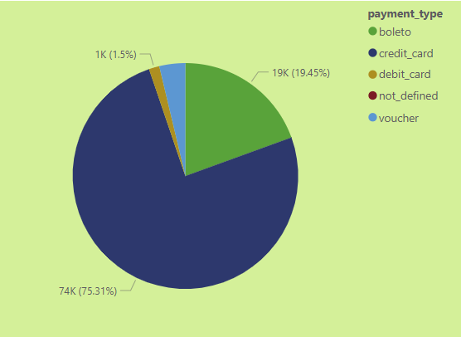

More than **75%** of all transactions were carried out via **credit cards** and about **20%** of the payments were done through **boleto.**

**Debit Cards** Payments were the least of all the payment methods.

**5. Product rating analysis**

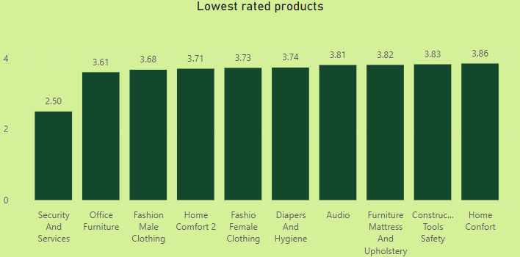

**Security and Services** products are the lowest rated with an average rating close to **2.50**.

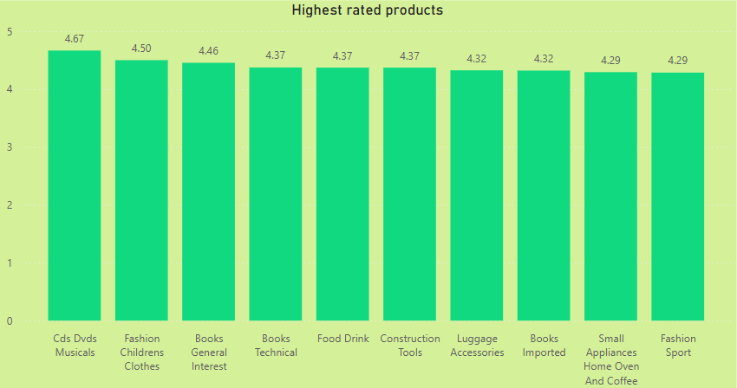

**CDs DVDs Musicals** products are the highest rated with an average rating close to **4.67**.

**6. State-wise Sales Analysis**

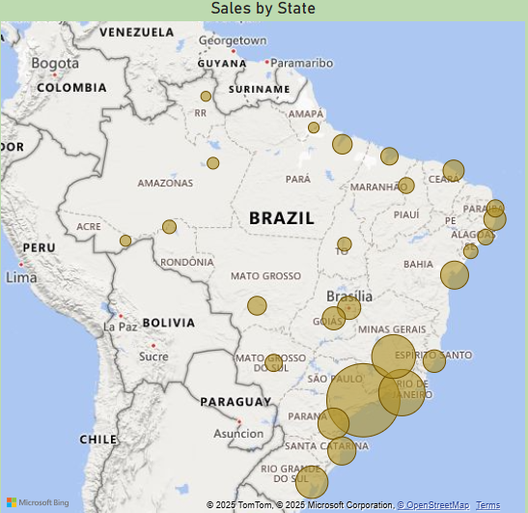

**Sao Paulo, the most populous state of Brazil**, generated the most amount of sales clocking more than **5 million** Brazilian Real. Rio de Janeiro and Minas Gerais, the second and third most populous states stood second and third respectively per the total sales. This is in line with the expectations because these three are the most populous states.

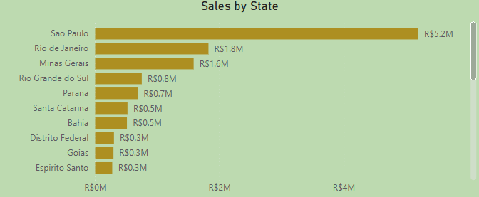

**7. Seasonal Sales Pattern**

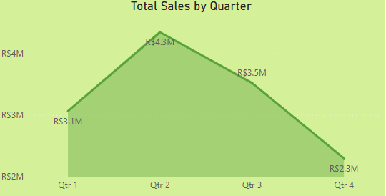

**Quarter 2** witnessed the most amount of sales as is evident from the number of orders.

Though the number of orders were highest in **August** but there was a sharp dip in number of orders in September probably due to which the sales also suffered a hit and eventually, the sales in Quarter 3 were lower than those in Quarter 2.

**8. Revenue Analysis**

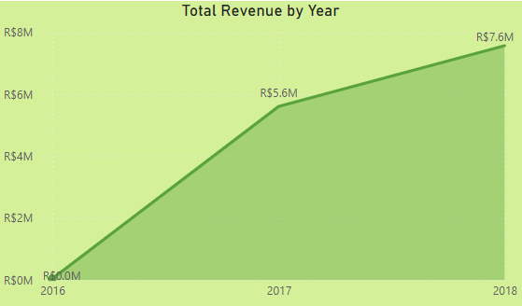

Revenue in 2016 was less than **0.5 million** Brazilian Real. It may be probably because the store commenced its’ operations in **October 2016** and there were only **272** orders.

Revenue in 2017 skyrocketed and stood at more than **5.5** **million** Brazilian Real. Then, in 2018, there was about **35%** increase in revenue and it stood at near **7.6** million Brazilian Real.